title

First name1 SURNAME1¹, First name2 SURNAME2²,…
¹ University, faculty (Country)
² University, faculty (Country)
…
e-mail1, e-mail2,…

Abstract
Summary of the main ideas of the paper, 400 to 800 characters including spaces. (Basic text style)

Keywords:

- Introduction
The paper can be written in Czech, Slovak, Polish and English. The recommended number of pages is 5 - 10 (including tables, figures and references).

- Chapter title
Please use the set A4 page layout: all margins are 2.5 cm, font type Times New Roman, font size 12 b., simple spacing, offset the first line in a paragraph by 0.7 cm. Don't number the pages.

  - Subchapter title
In the text, you can use numbered lists, bulleted lists, figures, mathematical expressions in common MS Word equation editors, charts, tables.

For a numbered list, use the following format:
- row
- row
- row

For a bulleted list, use the following format:
- bullet 1
- bullet 2
- bullet 3

Tables, charts and figures
Numbered tables, graphs and figures insert directly into the text. Tables, charts, and figures should not exceed the selected margins of the document. Align tables to the left, charts and figures to the middle.

Table 1. Table Name
order | points | version | order | points | version
1. | 50 | B | 9. | 36 | B
1. | 50 | B | 10. | 35 | A
2. | 47 | B | 10. | 35 | A
3. | 42 | B | 10. | 35 | B
4. | 41 | A | 10. | 35 | B
4. | 41 | B | 11. | 31 | A
5. | 40 | A | 12. | 30 | B
5. | 40 | B | 13. | 26 | A
6. | 39 | A | 13. | 26 | B
7. | 38 | A | 14. | 24 | A
7. | 38 | A | 15. | 23 | A
8. | 37 | A | 16. | 21 | B
9. | 36 | A | 17. | 20 | B
9. | 36 | B

Chart 1. Chart title

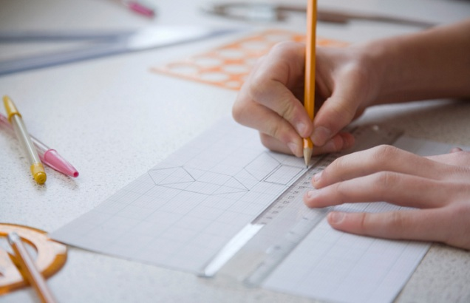
Figure 1. Image name

- Conclusion
Briefly summarize the main ideas contained in the article and the possible results of the research.

Acknowledgements
Here, if you need, you can give thanks or a link to the project, which was an article or research supported.

References
Writing citations (list of literature) and references to citations process according to APA (see examples). List the literature alphabetically.

Reference to an article in journal:
Bártek, K., & Nocar, D. (2018). The use of digital learning objects for effective mathematics instruction. Contemporary Educational Researches Journal (CERJ), 8 (2), 50-56.
Reference to a monograph:
Dofková, R. (2016). Přesvědčení o připravenosti budoucích učitelů matematiky jako didaktická výzva primárního vzdělávání. Olomouc: Univerzita Palackého v Olomouci.
Reference to an article in electronic Journal:
Partová, E., & Žilková, K. (2018). Mobilné aplikácie na porozumenie pojmu usporadanie. Magister: reflexe primárního a preprimáního vzdělávání ve výzkumu, 2018(1), 37–51. Retrieved from URL http://kpv.upol.cz/download/magister/Magister_2-2018.pdf
Reference to a contribution in proceedings:
Tang, Q., Laitochová, J., Nocar, D., & Bártek, K. (2017). The depth fusion of education in elementary school and information technology - based on the analysis of questionnaires. In: EDULEARN17 Proceedings (s. 8490-8495). Valencia: IATED.

